**Nhóm 12**

**Cài đặt mail server sử dụng Zimbra 8.8**

# I) Yêu cầu hệ thống cơ bản:

- Hệ điều hành: Ubuntu 16.04 LTS 64bit.

- Phiên bản Zimbra: 8.8.10_GA_3039.UBUNTU16_64.20180928094617.

- RAM: 4Gb.

# II) Các bước cài đặt Zimbra mail server:

$sudo apt-get update

$sudo apt-get upgrade

$sudo apt-get dist-upgrade

## Bước 1: Config OS phục vụ cho Zimbra Collaboration:

### 1) Đăng nhập root user:

oper@zimbra:~$ sudo su

[sudo] password for oper:

root@ zimbra:/home/oper#

### 2) Chỉnh sửa hostname thành “mail”:

root@ zimbra:~# nano /etc/hostname

*Sửa thành:*

zimbra

*Xong rồi reboot:*

root@ zimbra:~# reboot

### 3) Nếu như hệ thống đã config bằng DHCP thì cần IP tĩnh (static ip) cho Zimbra:

root@ zimbra:~# nano /etc/network/interfaces

*• Thay đổi 1 số dòng sau để thiết lập IP tĩnh:*

allow-hotplug eth0

iface eth0 inet static

address 192.X.X.X

netmask 255.255.255.0

gateway 192.X.X.X

dns-nameservers 127.0.0.1

dns-nameservers 8.8.8.8

***Thay đổi giá trị 192.X.X.X tùy theo máy của bạn.***

### 4) Kiểm tra các DNS đang sử dụng:

root@ zimbra:~# nano /etc/resolv.conf

*• Kiểm tra và thêm các giá trị như sau:*

# Dynamic resolv.conf(5) file for glibc resolver(3) generated by #resolvconf(8)

# DO NOT EDIT THIS FILE BY HAND -- YOUR CHANGES WILL BE #OVERWRITTEN

nameserver 127.0.0.1

nameserver 8.8.8.8

### 5) Thêm IP và tên miền cho mailserver:

root@ zimbra: /home/oper# nano /etc/hosts

*• Thêm như sau:*

127.0.0.1 localhost

192.X.X.X zimbra.cnm14.io zimbra

# The following lines are desirable for IPv6 capable hosts

::1 localhost ip6-localhost ip6-loopback

ff02::1 ip6-allnodes

ff02::2 ip6-allrouters

***Thay đổi giá trị 192.X.X.X tùy theo máy của bạn.***

### 5) Reboot lại hệ thống:

root@zimbra:~# reboot

### 6) Kiểm tra lại tên host:

root@zimbra:~# hostname

zimbra

root@zimbra:~# hostname –f

zimbra.cnm14.io

## Bước 2: Cài đặt DNS Server (dnsmasq)

Để cài cặt Zimbra mail server với quy mô nhỏ thì chúng ta nên sử dnsmasq bên trong Zimbra Collaboration Server.

### 1) Cài đặt dnsmasq:

apt-get install dnsmasq

Reading package lists... Done

Building dependency tree

Reading state information... Done

The following NEW packages will be installed:

dnsmasq

0 upgraded, 1 newly installed, 0 to remove and 4 not upgraded.

Need to get 15.9 kB of archives.

After this operation, 71.7 kB of additional disk space will be used.

**Do you want to continue? [Y/n] y**

### 2) Thiết lập dnsmasq tùy vào hệ thống của bạn:

root@zimbra:~# nano /etc/dnsmasq.conf

*• Thêm vào những dòng sau:*

server=8.8.8.8

listen-address=127.0.0.1

domain=cnm14.io

mx-host= cnm14.io,zimbra.cnm14.io,0

address=/cnm14.zimbra.io/192.X.X.X

***Thay đổi giá trị 192.X.X.X tùy theo máy của bạn.***

### 3) Restart dnsmasq:

root@zimbra:/home/oper# service dnsmasq restart

### 4) Kiểm tra trạng thái của DNS:

*• Kiểm tra trạng thái MX:*

root@zimbra:~# dig mx cnm14.io

<<>> DiG 9.10.3-P4-Ubuntu <<>> mx cnm14.io

;; global options: +cmd

;; Got answer:

;; ->>HEADER<<- opcode: QUERY, status: NOERROR, id: 11345

;; flags: qr aa rd ra ad; QUERY: 1, ANSWER: 1, AUTHORITY: 0, ADDITIONAL: 2

;; OPT PSEUDOSECTION:

; EDNS: version: 0, flags:; udp: 1280

;; QUESTION SECTION:

;cnm14.io. IN MX

;; ANSWER SECTION:

zimbra.io. 0 IN MX 0 zimbra.cnm14.io.

;; ADDITIONAL SECTION:

zimbra.cnm14.io. 0 IN A 192.X.X.X

;; Query time: 0 msec

;; SERVER: 127.0.0.1#53(127.0.0.1)

;; WHEN: Thu Sep 11 18:06:43 UTC 2018

;; MSG SIZE rcvd: 87

*• Kiểm tra trạng thái DNS:*

root@zimbra:~# dig zimbra.cnm14.io

; <<>> DiG 9.10.3-P4-Ubuntu <<>> zimbra.cnm14.io

;; global options: +cmd

;; Got answer:

;; ->>HEADER<<- opcode: QUERY, status: NOERROR, id: 56775

;; flags: qr aa rd ra; QUERY: 1, ANSWER: 1, AUTHORITY: 0, ADDITIONAL: 1

;; OPT PSEUDOSECTION:

; EDNS: version: 0, flags:; udp: 1280

;; QUESTION SECTION:

; zimbra.cnm14.io. IN A

;; ANSWER SECTION:

zimbra.cnm14.io. 0 IN A 192.X.X.X

;; Query time: 0 msec

;; SERVER: 127.0.0.1#53(127.0.0.1)

;; WHEN: Thu Sep 11 18:09:32 UTC 2018

;; MSG SIZE rcvd: 62

## Bước 3: Cài đặt Zimbra 8.8.10

1) Để có thể tải phiên bản mới nhất của zimbra hiện tại là 8.8.10_GA bạn vào trang chủ của zimbra đăng ký tài khoản để có thể sử dụng bản không thu phí:

<https://www.zimbra.com/downloads/zimbra-collaboration/>

### 2) Sau khi tải về thì tệp tin có dạng:

zcs-8.8.10_GA_3039.UBUNTU16_64.20180928094617.tgz

### 3) Giải nén và cài đặt:

root@zimbra:/home/oper# tar xzvf zcs-8.8.10_GA_3039.UBUNTU16_64.20180928094617.tgz

*• Di chuyển đến thư mục vừa giải nén:*

root@zimbra8:/home/oper# cd zcs-8.8.10_GA_3039.UBUNTU16_64.20180928094617

*• Cài đặt:*

root@zimbra:~/ zcs-8.8.10_GA_3039.UBUNTU16_64.20180928094617# ./install.sh

• *Tiến trình cài đặt bắt đầu, chú ý những giá trị Yes/No:*

WARNING: ZCS is currently only supported on Ubuntu Server 12.04 and 14.04 LTS. You are attempting to install on Ubuntu 16.04.1 LTS which may not work. Support will not be provided if you choose to continue.

**Do you wish to continue? [N] y**

Operations logged to /tmp/install.log.4P2y60cn

Checking for existing installation...

zimbra-ldap...NOT FOUND

zimbra-logger...NOT FOUND

zimbra-mta...NOT FOUND

zimbra-dnscache...NOT FOUND

zimbra-snmp...NOT FOUND

zimbra-store...NOT FOUND

zimbra-apache...NOT FOUND

zimbra-spell...NOT FOUND

zimbra-convertd...NOT FOUND

zimbra-memcached...NOT FOUND

zimbra-proxy...NOT FOUND

zimbra-archiving...NOT FOUND

zimbra-core...NOT FOUND

----------------------------------------------------------------------

PLEASE READ THIS AGREEMENT CAREFULLY BEFORE USING THE SOFTWARE.

SYNACOR, INC. ("SYNACOR") WILL ONLY LICENSE THIS SOFTWARE TO YOU IF YOU FIRST ACCEPT THE TERMS OF THIS AGREEMENT. BY DOWNLOADING OR INSTALLING THE SOFTWARE, OR USING THE PRODUCT, YOU ARE CONSENTING TO BE BOUND BY THIS AGREEMENT. IF YOU DO NOT AGREE TO ALL OF THE TERMS OF THIS AGREEMENT, THEN DO NOT DOWNLOAD, INSTALL OR USE THE PRODUCT.

License Terms for this Zimbra Collaboration Suite Software:

https://www.zimbra.com/license/zimbra-public-eula-2-6.html

----------------------------------------------------------------------

Do you agree with the terms of the software license agreement? [N] y

7/22Checking for installable packages

Found zimbra-core

Found zimbra-ldap

Found zimbra-logger

Found zimbra-mta

Found zimbra-dnscache

Found zimbra-snmp

Found zimbra-store

Found zimbra-apache

Found zimbra-spell

Found zimbra-memcached

Found zimbra-proxy

**Use Zimbra's package repository [Y] y**

Configuring package repository

Select the packages to install

**Install zimbra-ldap [Y] y**

**Install zimbra-logger [Y] y**

**Install zimbra-mta [Y] y**

**Install zimbra-dnscache [Y] n**

**Install zimbra-snmp [Y] y**

**Install zimbra-store [Y] y**

**Install zimbra-apache [Y] y**

**Install zimbra-spell [Y] y**

**Install zimbra-memcached [Y] y**

**Install zimbra-proxy [Y] y**

Checking required space for zimbra-core

Checking space for zimbra-store

Checking required packages for zimbra-store

zimbra-store package check complete.

Installing:

zimbra-core

zimbra-ldap

zimbra-logger

zimbra-mta

zimbra-snmp

zimbra-store

zimbra-apache

8/22zimbra-spell

zimbra-memcached

zimbra-proxy

**The system will be modified. Continue? [N] y**

Removing /opt/zimbra

Removing zimbra crontab entry...done.

Cleaning up zimbra init scripts...done.

Cleaning up /etc/security/limits.conf...done.

Finished removing Zimbra Collaboration Server.

Installing packages

Local packages zimbra-core zimbra-ldap zimbra-logger zimbra-mta zimbra-snmp zimbrastore zimbra-apache zimbra-spell zimbra-proxy selected for installation

Monitor /tmp/install.log.4P2y60cn for package installation progress

Remote package installation started

Installing zimbra-core-components zimbra-ldap-components zimbra-mta-components zimbrasnmp-components zimbra-store-components zimbra-apache-components zimbra-spellcomponents zimbra-memcached zimbra-proxy-components....

Local package installation started

Installing zimbra-core zimbra-ldap zimbra-logger zimbra-mta zimbra-snmp zimbra-store

zimbra-apache zimbra-spell zimbra-proxy...

done

Unescaped left brace in regex is deprecated, passed through in regex; marked by <-- HERE in

m/\${ <-- HERE zimbra_home}/ at /opt/zimbra/libexec/zmupgrade.pm line 1514, <DATA>

line 755.

Unescaped left brace in regex is deprecated, passed through in regex; marked by <-- HERE in

m/\${ <-- HERE zimbra_home}/ at /opt/zimbra/libexec/zmupgrade.pm line 1557, <DATA>

line 755.

Unescaped left brace in regex is deprecated, passed through in regex; marked by <-- HERE in

m/\${ <-- HERE zimbra_home}/ at /opt/zimbra/libexec/zmupgrade.pm line 1686, <DATA>

line 755.

Unescaped left brace in regex is deprecated, passed through in regex; marked by <-- HERE in

m/\${ <-- HERE zimbra_home}/ at /opt/zimbra/libexec/zmupgrade.pm line 1727, <DATA>

line 755.

Unescaped left brace in regex is deprecated, passed through in regex; marked by <-- HERE in

m/\${ <-- HERE zimbra_home}/ at /opt/zimbra/libexec/zmupgrade.pm line 1736, <DATA>

line 755.

Unescaped left brace in regex is deprecated, passed through in regex; marked by <-- HERE in

m/\${ <-- HERE zimbra_home}/ at /opt/zimbra/libexec/zmupgrade.pm line 1745, <DATA>

line 755.

Unescaped left brace in regex is deprecated, passed through in regex; marked by <-- HERE in

m/\${ <-- HERE zimbra_home}/ at /opt/zimbra/libexec/zmupgrade.pm line 1754, <DATA>

line 755.

9/22Unescaped left brace in regex is deprecated, passed through in regex; marked by <-- HERE in

m/\${ <-- HERE zimbra_home}/ at /opt/zimbra/libexec/zmupgrade.pm line 1763, <DATA>

line 755.

Operations logged to /tmp/zmsetup.20160804-170455.log

Installing LDAP configuration database...done.

Setting defaults...

DNS ERROR resolving MX for mail.zimbra-demo.com

It is suggested that the domain name have an MX record configured in DNS

**Re-Enter domain name? [Yes] yes**

**Create domain: [zimbra.cnm14.io] cnm14.io**

MX: mail.zimbra-demo.com (192.X.X.X) //Tùy theo máy

Interface: 192.X.X.X //Tùy theo máy

Interface: 127.0.0.1

Interface: ::1

done.

Checking for port conflicts

Main menu

1) Common Configuration:

2) zimbra-ldap: Enabled

3) zimbra-logger: Enabled

4) zimbra-mta: Enabled

5) zimbra-snmp: Enabled

6) zimbra-store: Enabled

+Create Admin User: yes

+Admin user to create: admin@cnm14.io

******* +Admin Password UNSET

+Anti-virus quarantine user: virus-quarantine.h4n6gggw@cnm14.io

+Enable automated spam training: yes

+Spam training user: spam.wv02wfpi@cnm14.io

+Non-spam(Ham) training user: ham.c4zyg7r9m@cnm14.io

+SMTP host: zimbra.cnm14.io

+Web server HTTP port: 8080

+Web server HTTPS port: 8443

+Web server mode: https

+IMAP server port: 7143

+IMAP server SSL port: 7993

+POP server port: 7110

+POP server SSL port: 7995

+Use spell check server: yes

+Spell server URL: http://zimbra.cnm14.io:7780/aspell.php

+Enable version update checks: TRUE

+Enable version update notifications: TRUE

+Version update notification email: admin@cnm14.io

+Version update source email: admin@cnm14.io

10/22+Install mailstore (service webapp): yes

+Install UI (zimbra,zimbraAdmin webapps): yes

7) zimbra-spell: Enabled

8) zimbra-proxy: Enabled

9) Default Class of Service Configuration:

s) Save config to file

x) Expand menu

q) Quit

**Address unconfigured (**) items (? - help) 6** //Để thiết lập password

-----------------------------------------------------------------------------------

Store configuration

1) Status: Enabled

2) Create Admin User: yes

3) Admin user to create: admin@cnm14.io

** 4) Admin Password UNSET

5) Anti-virus quarantine user: virus-quarantine.h4n6gggw@cnm14.io

6) Enable automated spam training: yes

7) Spam training user: spam.wv02wfpi@cnm14.io

8) Non-spam(Ham) training user: ham.c4zyg7r9m@cnm14.io

9) SMTP host: zimbra.cnm14.io

10) Web server HTTP port: 8080

11) Web server HTTPS port: 8443

12) Web server mode: https

13) IMAP server port: 7143

14) IMAP server SSL port: 7993

15) POP server port: 7110

16) POP server SSL port: 7995

17) Use spell check server: yes

18) Spell server URL: http://zimbra.cnm14.io:7780/aspell.php

19) Enable version update checks: TRUE

20) Enable version update notifications: TRUE

21) Version update notification email: admin@cnm14.io

22) Version update source email: admin@cnm14.io

23) Install mailstore (service webapp): yes

24) Install UI (zimbra,zimbraAdmin webapps): yes

**Select, or 'r' for previous menu [r] 4** //Đặt password

-------------------------------------------------------------------------------------

**Password for admin@cnm14.io (min 6 characters): [gbjep4Py1] 123456**

Store configuration

1) Status: Enabled

2) Create Admin User: yes

3) Admin user to create: admin@cnm14.io

4) Admin Password set

5) Anti-virus quarantine user: virus-quarantine.h4n6gggw@cnm14.io

6) Enable automated spam training: yes

7) Spam training user: spam.wv02wfpi@cnm14.io

8) Non-spam(Ham) training user: ham.c4zyg7r9m@cnm14.io

9) SMTP host: zimbra.cnm14.io

10) Web server HTTP port: 8080

11) Web server HTTPS port: 8443

12) Web server mode: https

13) IMAP server port: 7143

14) IMAP server SSL port: 7993

15) POP server port: 7110

16) POP server SSL port: 7995

17) Use spell check server: yes

18) Spell server URL: http://zimbra.cnm14.io:7780/aspell.php

19) Enable version update checks: TRUE

20) Enable version update notifications: TRUE

21) Version update notification email: admin@ cnm14.io

22) Version update source email: admin@ cnm14.io

23) Install mailstore (service webapp): yes

24) Install UI (zimbra,zimbraAdmin webapps): yes

**Select, or 'r' for previous menu [r] r** //Trở lại menu

--------------------------------------------------------------------------

Main menu

1) Common Configuration:

2) zimbra-ldap: Enabled

3) zimbra-logger: Enabled

4) zimbra-mta: Enabled

5) zimbra-snmp: Enabled

6) zimbra-store: Enabled

7) zimbra-spell: Enabled

8) zimbra-proxy: Enabled

9) Default Class of Service Configuration:

s) Save config to file

x) Expand menu

q) Quit

// Ấn a để lưu

**\*\*\* CONFIGURATION COMPLETE - press 'a' to apply**

**Select from menu, or press 'a' to apply config (? - help) a**

**Save configuration data to a file? [Yes] yes**

Save config in file: [/opt/zimbra/config.31029] Saving config in

/opt/zimbra/config.31029...done.

**The system will be modified - continue? [No] yes**

Operations logged to /tmp/zmsetup.20160804-170455.log

Setting local config values...done.

Initializing core config...Setting up CA...done.

Deploying CA to /opt/zimbra/conf/ca ...done.

Creating SSL zimbra-store certificate...done.

Creating new zimbra-ldap SSL certificate...done.

Creating new zimbra-mta SSL certificate...done.

Creating new zimbra-proxy SSL certificate...done.

Installing mailboxd SSL certificates...done.

Installing MTA SSL certificates...done.

Installing LDAP SSL certificate...done.

Installing Proxy SSL certificate...done.

Initializing ldap...done.

Setting replication password...done.

Setting Postfix password...done.

Setting amavis password...done.

Setting nginx password...done.

Setting BES searcher password...done.

Creating server entry for zimbra.cnm14.io...done.

Setting Zimbra IP Mode...done.

Saving CA in ldap...done.

Saving SSL Certificate in ldap...done.

Setting spell check URL...done.

Setting service ports on mail.zimbra-demo.com...done.

Setting zimbraFeatureTasksEnabled=TRUE...done.

Setting zimbraFeatureBriefcasesEnabled=TRUE...done.

Checking current setting of zimbraReverseProxyAvailableLookupTargets

Querying LDAP for other mailstores

Searching LDAP for reverseProxyLookupTargets...done.

Adding mail.zimbra-demo.com to zimbraReverseProxyAvailableLookupTargets

Setting TimeZone Preference...done.

Initializing mta config...done.

Setting services on mail.zimbra-demo.com...done.

Adding mail.zimbra-demo.com to zimbraMailHostPool in default COS...done.

Creating domain cnm14.io...done.

Setting default domain name...done.

Creating domain cnm14.io...already exists.

Creating admin account admin@cnm14.io...done.

Creating root alias...done.

Creating postmaster alias...done.

14/22Creating user spam.wv02wfpi@cnm14.io...done.

Creating user ham.c4zyg7r9m@cnm14.io...done.

Creating user virus-quarantine.h4n6gggw@cnm14.io...done.

Setting spam training and Anti-virus quarantine accounts...done.

Initializing store sql database...done.

Setting zimbraSmtpHostname for mail. cnm14.io...done.

Configuring SNMP...done.

Setting up syslog.conf...done.

Starting servers...done.

Installing common zimlets...

com_zimbra_mailarchive...done.

com_zimbra_srchhighlighter...done.

com_zimbra_viewmail...done.

com_zimbra_attachmail...done.

com_zimbra_url...done.

com_zimbra_ymemoticons...done.

com_zimbra_cert_manager...done.

com_zimbra_proxy_config...

com_zimbra_url...done.

com_zimbra_ymemoticons...done.

com_zimbra_cert_manager...done.

com_zimbra_proxy_config...done.

com_zimbra_adminversioncheck...done.

com_zimbra_tooltip...done.

com_zimbra_date...done.

com_zimbra_webex...done.

com_zimbra_email...done.

com_zimbra_bulkprovision...done.

com_zimbra_attachcontacts...done.

com_zimbra_phone...done.

com_zimbra_clientuploader...done.

Finished installing common zimlets.

Restarting mailboxd...done.

Creating galsync account for default domain...done.

You have the option of notifying Zimbra of your installation.

This helps us to track the uptake of the Zimbra Collaboration Server.

The only information that will be transmitted is:

The VERSION of zcs installed (8.8.10_GA_3039.UBUNTU16_64)

The ADMIN EMAIL ADDRESS created (admin@cnm14.io)

**Notify Zimbra of your installation? [Yes] Notifying Zimbra of installation via**

http://www.zimbra.com/cgi-bin/notify.cgi?

VER= 8.8.10_GA_3039.UBUNTU16_64 &MAIL=admin@cnm14.io

15/22Notification complete

Setting up zimbra crontab...done.

Moving /tmp/zmsetup.20160804-154559.log to /opt/zimbra/log

**Configuration complete - press return to exit**

*• Như vậy là đã cài đặt xong, vào browser và truy cập đường link:*

<https://zimbra.cnm14.io/7071>

# III) Giao diện:

*• Chú ý: Để có thể gửi mail cho nhau thì các máy trong 1 mạng phải thông nhau.*

## 1) Giao diện đăng nhập Admin:

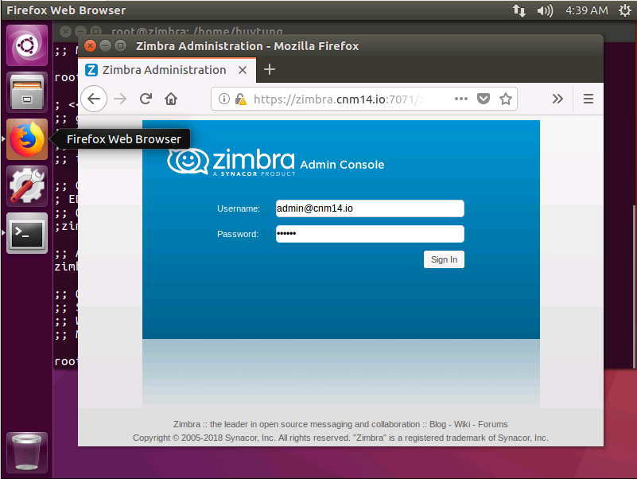

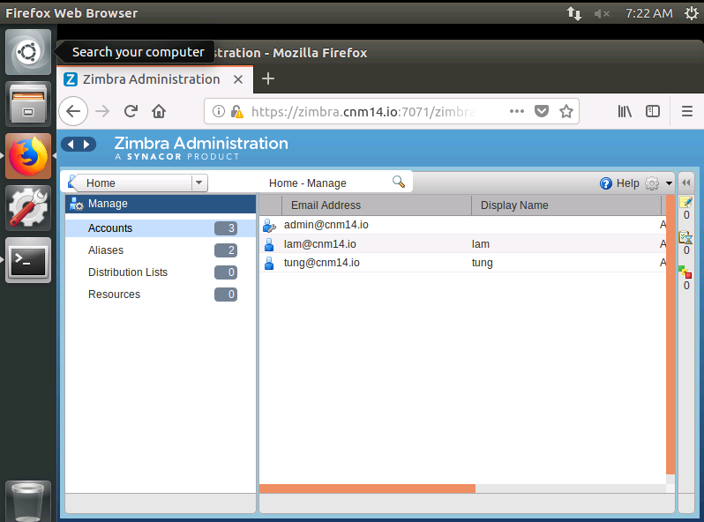

## 2) Giao diện đăng nhập Client:

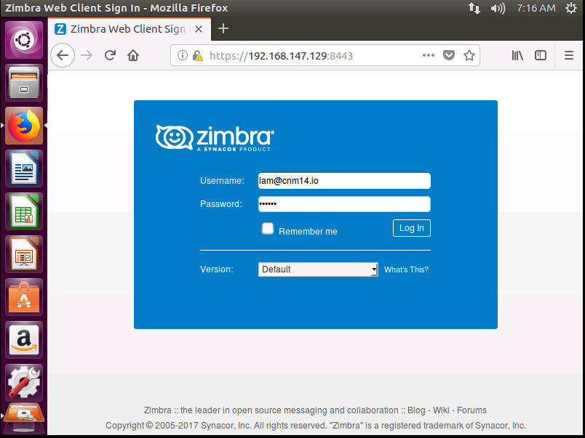

## 3) Giao diện gửi và nhận:

